NETWORKING 5

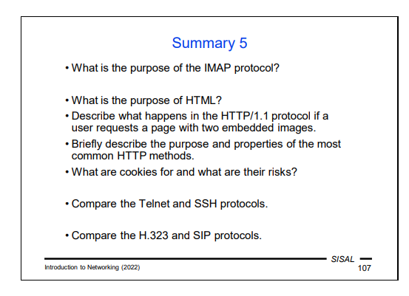
- IMAP – reading and searching, not sending, potentially very different

- HTML – content and format of text plus additionally some content like pictures

3) 1. 1. Version -> one request gets the reference for the page and all other requests refer directly to the requested content, each request is independent

- Post,put,delete and connect can work with the files

- Cookies are binary data made by the server so that it can keep a logical server state so that the server(and the protocol) is stateful

- TelNet = Telecommunication Network

- Authentication: username, password -> basic

- Secure Shell = SSH it is not possible to use this server everywhere in the world (e.g. Warsaw Airport)

- If we connect through https we can trick their server to think we are actually not working with SSH
- The client verifies the server and it is encrypted
- The server sends a public key and the client verifies the server identity based on that public key received
- Most common -> username and key usage strategy
- The server sends you a public key, usually a fingerprint (hash of that key) and the user has to check the fingerprint of that key
- If the server changed the key, you HAVE to check it, either with the company or the key holder
- Internet worms can attack or more carefully said, have access to a server if you connected passwordless from a to b and from b to a
In the protocol from the 80’s you have to read bit by bit
HUGE disadvantage: if a version changed, you have one more extra bit for the same data, how do you access and make the difference?

100=everything is ok, trying to do something

What is the purpose of the IMAP protocol?
The IMAP protocol is widely used by most MUA for remote access to mail. It included e.g. commands to search for a message in a mailbox according to several criteria, or to download only certain information about a message. In terms of security, it is used in combination with TLS, either on the dedicated port 993 instead of 143, or on demand by a STARTTLS command issued by the client.

What is the purpose of HTML?
HTML (Hypertext Markup Language), which contains means for expressing both content (i.e. text, embedded images, links, etc.) and form (font, color, tables, alignment, etc.). HTML describes an author's idea of how a page should be displayed on the client's screen, but the exact appearance of the displayed page is determined by many other factors (implementation of the language's properties in the browser, user settings, etc.).

Describe what happens in the HTTP/1.1 protocol if a user requests a page with two embedded images.
-------A classic example is a page with images –in version 1 we learned that the client must create a new request for each image, but in version 2 it is not necessary.
A single page request results in multiple independent HTTP requests for the resources (in this case, the images) specified in the HTML. If the page also has text, the client will send 3 requests, otherwise 2, in order to get the whole content of the page. Version 1.1 introduced a new feature, a persistent connection, which means that after one request, the client does not have to close the TCP connection and establish a new one, but can use the same TCP connection for multiple serial requests. The fact that the individual requests are independent means that the entire communication is stateless, or that the server generally has no idea of which requests from the same client "belong together" or about the current state of the interaction with a given user.

Briefly describe the purpose and properties of the most common HTTP methods.
Get
Head
Post
Put
Delete
Connect

What are cookies for and what are their risks?
Cookies are for the server to collect data about the client. Cookies’ purpose is to resolve the problem of stateless communication. A cookie is a piece of data that the server generates based on information from the user and sends to the client when responding, in the form of Set-Cookie (or Set-Cookie2) headers. Cookies themselves do not pose any direct risk; they cannot, for example, contain viruses, etc. However, they pose a secondary risk, because a web server can store any information it finds about the user in them and then use it at will.
-----------The browser saves this data and then sends it in the form of a Cookie header each time another request is submitted to the same server. A cookie lets a server identify the connection and/or user and ensure that the user’s request is processed in a server environment that matches their existing (or previous) interaction.

Compare the Telnet and SSH protocols.
Telnet is another very old protocol and represents the first solution for remote login to another machine, in the form of terminal emulation. The client and server transmit user commands and host reactions so that the user has an environment similar to sitting at a real terminal.
There are four messages DO ECHO, DON’T ECHO, WILL ECHO and WON’T ECHO. The problem is that the message does not indicate whether it is a command or a response! From a security point of view, Telnet has all the weaknesses of the old Internet protocols. However, even today, due to its relative simplicity, the protocol is used in places where there is no risk of password interception –for example, on a separate segment of a local network intended for infrastructure management. However, even these devices are switching to SSH over time.
SSH= Secured replacement of older protocols for remote access and file transfer. It is a protocol used for remote login and file transfers. Unlike older protocols, it is based on consistent authentication of the server to which we connect and encryption of the entire communication.
---- Currently, version 2 is used, which expands the capabilities of SSH with the following:
• opening parallel channels; it is possible, for example, to be logged in using a virtual terminal and to transfer files at the same time,
• tunneling; communication on one side of the SSH channel is transmitted through the channel and on the other side is directed to a local server (a way how to bypass a firewall),
• SSHFS; the server makes part of its file system available through the channel so that it appears to the client as a local file system.
--------comparison:
Telnet and SSH (Secure Shell) are both protocols used for remote access to network devices, but they differ significantly in terms of security and functionality:
Security:
Telnet: Transmits data in plaintext, which means that any information sent, including usernames and passwords, can be easily intercepted by an attacker. This makes Telnet very insecure for remote access over untrusted networks 122.
SSH: Provides a secure channel over an unsecured network by using encryption. It ensures that all data sent between the client and server is encrypted, making it much safer to use for remote access 124.
Authentication:
Telnet: Does not provide any secure authentication mechanisms. Users typically send their credentials in plaintext 122.
SSH: Supports various authentication methods, including password-based authentication and public key authentication, which enhances security 124.
Functionality:
Telnet: Primarily used for text-based communication and lacks advanced features. It is less flexible in terms of functionality compared to SSH 122.
SSH: Not only provides secure remote access but also supports features like secure file transfers (SCP, SFTP) and tunneling for other protocols, allowing for more versatile usage 124.
Protocol Maturity:
Telnet: One of the oldest protocols for remote access, defined in RFC 97 in 1971 122.
SSH: A more modern protocol that was developed to address the security shortcomings of Telnet and other protocols, with the current version being SSHv2 124.
In summary, while Telnet is simple and easy to use, its lack of security makes it unsuitable for most applications today, especially over the internet. SSH is the preferred choice due to its encryption and security features.

Compare the H.323 and SIP protocols.
The SIP is way simpler than H323 and easier to understand as SIP is a text protocol and H323 is a binary protocol.
- H.323: Utilizes a set of protocols for various functions, such as H.225 for call signaling and H.245 for media negotiation. It also uses RTP for media transport 102.
- SIP: Can run over both TCP and UDP, making it versatile in terms of transport options. SIP messages are sent in a text format, which makes them easier to work with

